Project Demo

|  |  |  |  |
| --- | --- | --- | --- |
|  |  |  |  |
| Project Name: | Desktop Refresh 2018 |  |  |
| Date: | 30/11/2021 | Release: | Final |
| Author: | Jonathan Pugh |  |  |
| Note: | This document is to be used in my personal portfolio as a demonstration of previous work.  **All personal information displayed in the screen shots attached to this document that is not my own has been redacted.** | | |

**Project definition**

The current desktops are now at the end of life and need to be replaced with updated models

The DTR projects aim was to capture the number of computers that we use on the various sites, who uses them, and what they use on the devices that might be unique to that device.

The information gathered will then be used to generate build sheets for the new computers to be deployed around the sites.

**Project objectives**

* Identify how many devices are required to be replaced
* Identify what unique software is on the devices if any
* Gather the information into a single source
* Generate build sheet to be provided to third party contractors
* Deploy new devices and remove old devices

**Project management team structure**

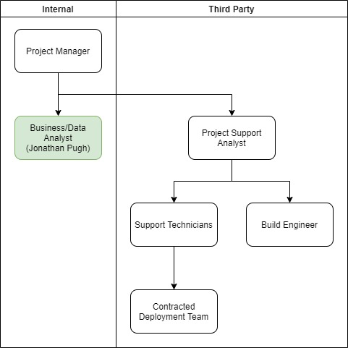

## Main Home Page

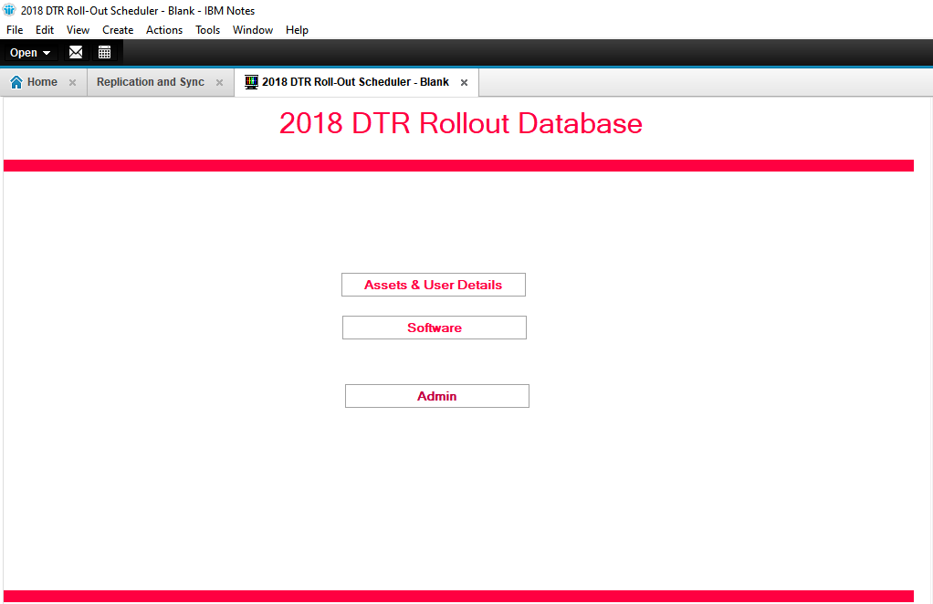

## Asset and User Details

### View Example - By Asset Tag and by New Type Views (Site and Owner Redacted)

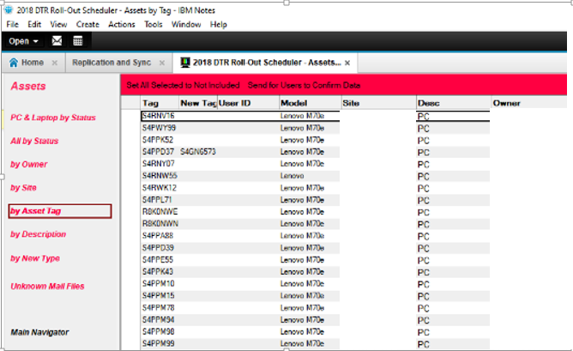

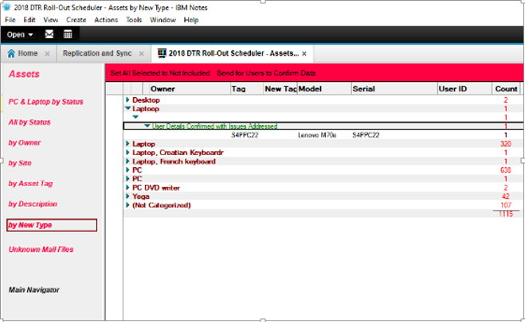

### User Form (User Details, Laptop/PC Details, and History tabs) (Telephone Number and Site Redacted)

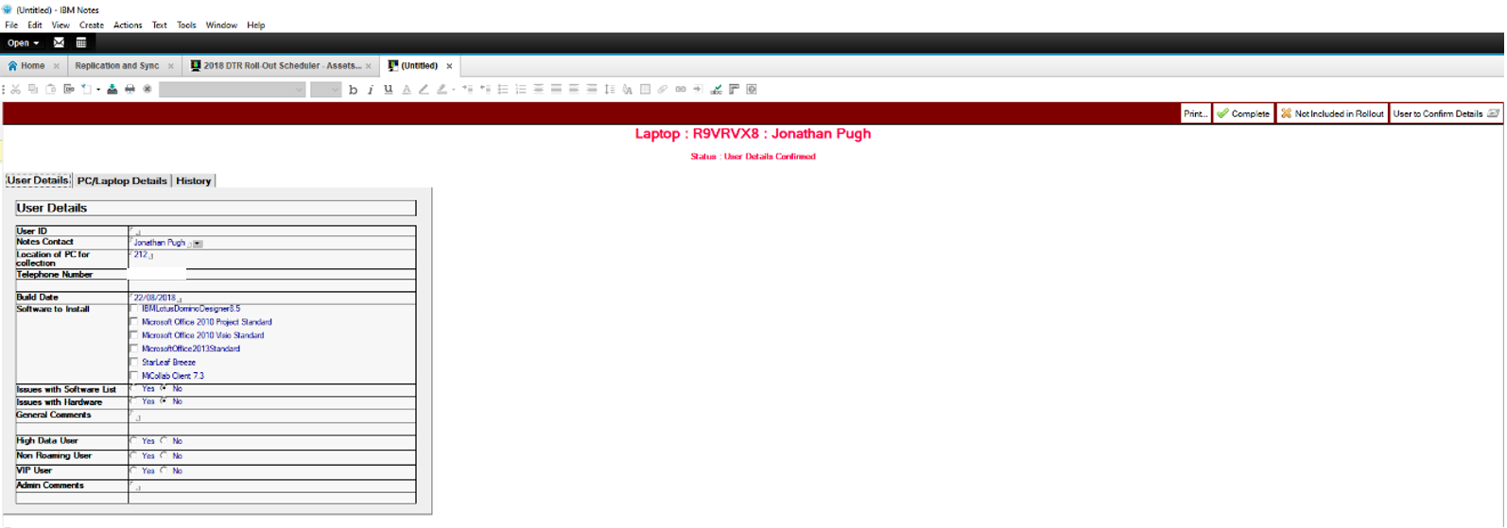

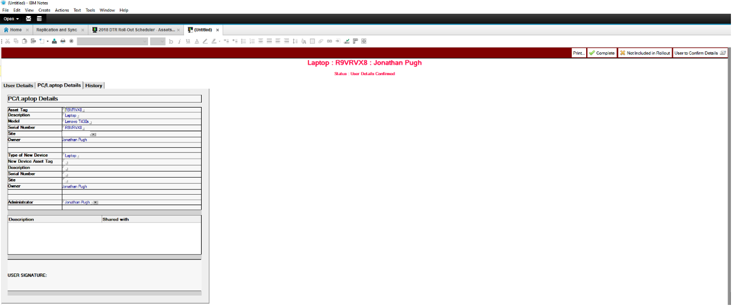

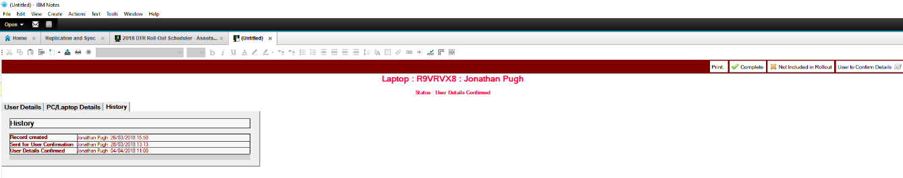

## Software

### Views Software by Name and by Asset

